Project Statement for Milestone 3
CollabInsight
Julia Lee, Son Nguyen, Tony Cao, Zirun Ye

Data Files:
For this milestone, we utilized a local CSV file, citation_network.csv, as our primary data source. The file contains metadata for academic papers and their citation relationships. The transformation step includes converting CSV strings to integers, extracting reference IDs, and batching imports for efficiency. We did not use any distributed data files.

Algorithms:
FingHightlyCitedPapers
Description:
- Identify highly Cited Papers
Input:
- citation_network.csv // raw data file
- Neo4j graph database with paper nodes, each having an attribute n_citation.
Output:
- A list of papers with n_citation ≥ 10, sorted in descending order, limited to 200 rows.
- A count visualization representing how many such papers exist in the sample.
Computing Operations:
- Filter nodes where p.n_citation >= 10.
- Sort them by citation count descending.
- Take the top 200 results.
- Save them to a text file.
- Plot the number of qualifying papers.
Pseudo-code:
query ← """
MATCH (p:Paper)
WHERE p.n_citation >= 10
RETURN p.paper_id, p.title, p.n_citation
ORDER BY p.n_citation DESC
LIMIT 200
"""
result ← execute(query)
write result to q2_highly_cited_papers.txt
plot bar chart with length(result)
return result

LoadFromNoSQL
Description:
- Load data from NoSQL (MongoDB)
Input:
- MongoDB collection storing author and coauthor records
Output:
- Authors, coauthor pairs
Procedure:
- Connect to MongoDB using Spark MongoDB Connector
- Load author records into Authors DataFrame
- Load coauthor relationship records into CoauthorPairs DataFrame
- RETURN Authors, CoauthorPairs
Pseudo-code:
Source code attached.

BuildGraph
Description:
- Build the collaboration graph
Input:
- Authors: list of author records CoauthorPairs: list of (AuthorA, AuthorB) pairs
Output:
- Graph G with vertices V and edges E
Procedure
- Create vertices V from Authors each vertex contains: author_id, name, affiliation
- Create edges E from CoauthorPairs; each edge: src = AuthorA, dst = AuthorB
- Construct GraphFrame G using vertices V and edges E
- Return Graph G
Pseudo-code:
Source code attached.

Bfs_n_hops
Description:
- BFS-based n-hop search
Input:
- G: GraphFrame startNode: author_id N: maximum hop count
Output:
- Paths: all reachable nodes within N hops from startNode
Procedure
- Set start condition: fromExpr = "id = startNode"
- Set search limit: maxPathLength = N
- toExpr = None (search any reachable node)
- Run BFS:
Paths = G.bfs(fromExpr, toExpr, maxPathLength)
- Return paths
Pseudo-code:
Source code attached.

Extract_hop_nodes
Description:
- Extract hop-level neighbor sets from GraphFrames BFS result.
Input:
- Paths_df (DataFrame): DataFrame returned from GraphFrames BFS
Output:
- HopDict
Procedure
- Initialize empty dictionary HopDict2. For each column name C in Paths:
if C starts with "v":
hop = integer extracted from C (example: "v2" > hop 2)
nodes = distinct non-null values from column C
HopDict[hop] = nodes
- Return HopDict
Pseudo-code:
Source code attached.

Optimization:
Several optimization techniques were implemented across the project’s algorithms to improve performance and scalability. For the Highly Cited Papers algorithm, a numeric filter (n_citation ≥ 10) is applied before sorting to significantly reduce the number of nodes processed, and the use of ORDER BY combined with LIMIT 200 allows the database engine to stop early once the top results are identified. Data loading is optimized through batch imports of 500 records and the use of MERGE with a unique constraint on paper_id, which prevents duplicate nodes and ensures fast lookups. In the graph construction pipeline, symmetric coauthor pairs such as (A, B) and (B, A) are removed, invalid or self-referencing pairs are filtered out, and schemas for vertices and edges are minimized to reduce memory usage. Distributed batch loading, parallel processing, and caching are also applied to speed up repeated computations.
In the hop extraction algorithm, unnecessary columns are avoided by processing only fields starting with “v,” and distributed operations such as select() and distinct() are used to prevent collecting large datasets prematurely; converting DataFrames to RDDs before collection further improves execution time. The BFS N-hop search is optimized by ensuring heavy computation is handled directly by Spark and GraphFrames, cleaning the graph to remove null edges and self-loops, using minimal schemas, and bounding BFS depth to keep the search space manageable. Together, these techniques enhance overall performance, reduce computational overhead, and improve scalability across all implemented algorithms.

Algorithm results:
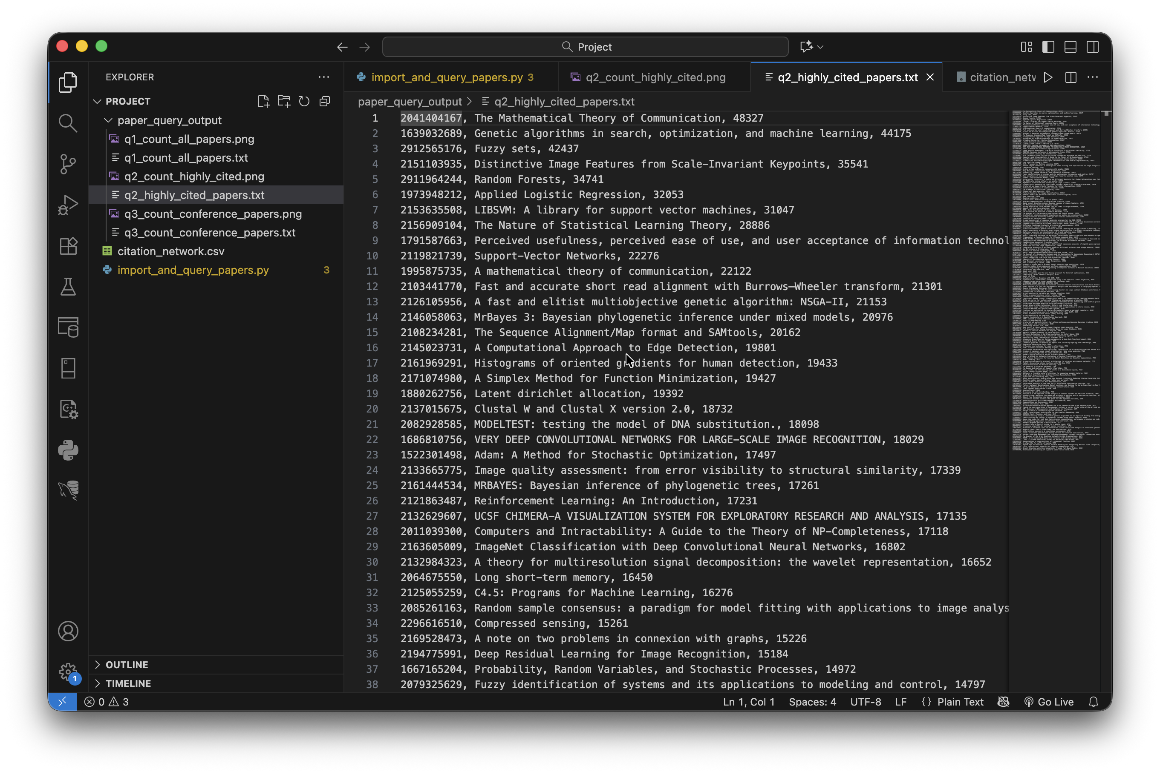
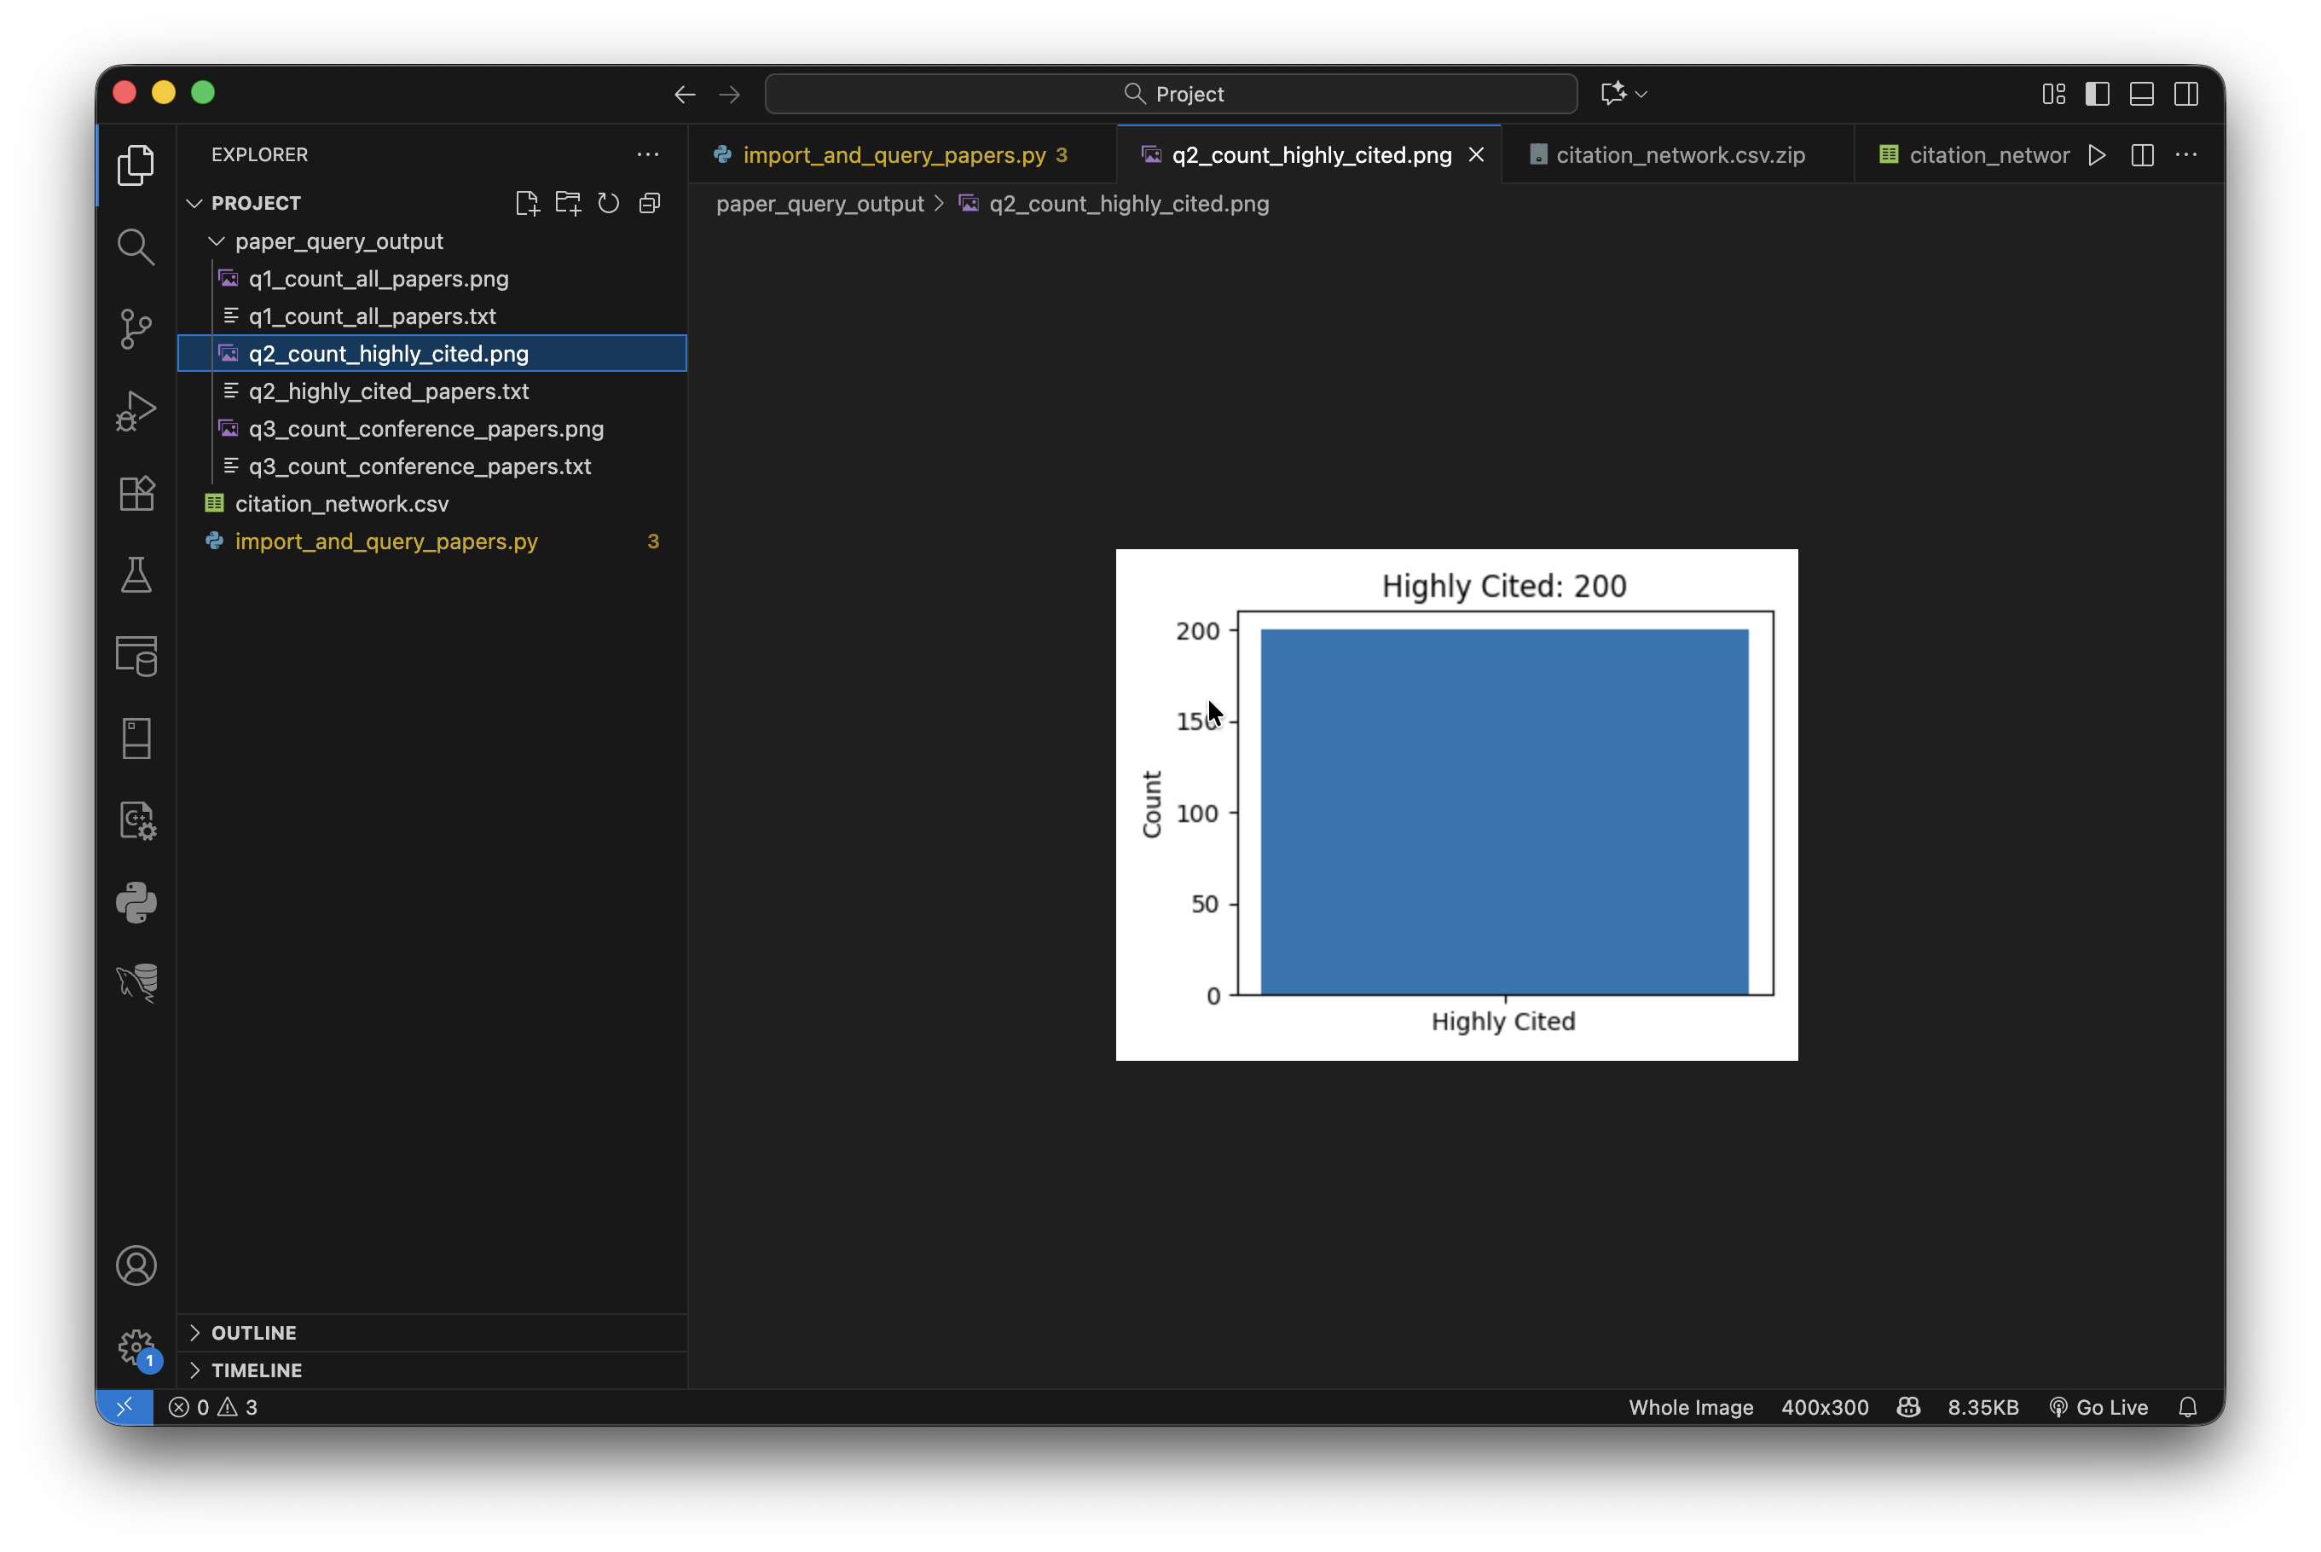
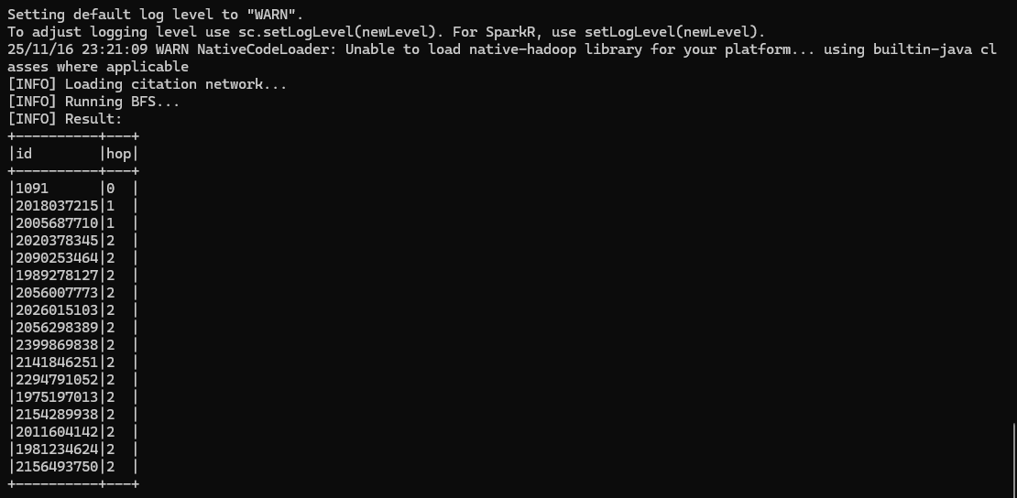

Performance:
For the Highly Cited Papers algorithm, the query completed almost instantly after the data import, requiring only a fraction of a second to filter, sort, and return the top 200 papers with at least 10 citations. As shown in the output screenshot, the algorithm successfully produced a count of 200 highly cited papers, and the results were written to both a text file and a bar chart. Because the query relies on a simple numeric filter (n_citation ≥ 10) and uses Neo4j’s optimized query engine, the execution is highly efficient even with a dataset of over four million papers. The results are exact (not approximate), since the algorithm performs a deterministic scan and uses built-in database operations without any randomness. Overall, the algorithm demonstrates fast runtime, accurate results, and low computational overhead.
Present results
To present the results to the user, we plan to execute all algorithms offline using prepared input data and store both the raw outputs and performance metrics. By precomputing and saving these results, the system can deliver them instantly on demand without requiring the user to wait for re-execution. This approach ensures fast response times, consistent outputs, and an overall smoother user experience. For algorithms such as BFS and hop-level extraction, storing precomputed results also avoids the need to recompute expensive graph operations each time, allowing users to quickly query collaboration patterns within the network.
Algorithm Scalability:
The team implemented the algorithms with scalability in mind. The design allows the workload to be distributed across multiple nodes so that larger datasets can be processed in parallel rather than sequentially. Data can be partitioned into smaller blocks that are stored across distributed storage systems like HDFS, enabling each node to handle only a portion of the computation. Because the algorithm minimizes shared state and reduces communication overhead between nodes, it can take advantage of distributed processing frameworks such as MapReduce or Spark. The BFS and hop-level extraction operations are executed as distributed DataFrame transformations, allowing Spark to partition the data across multiple nodes and process it in parallel. As more nodes are added, the system can process larger datasets and achieve faster execution times, allowing the algorithm to scale efficiently in distributed environments.

Source code: attached in the same folder.

